  
  
  
 Incyclist Manual

This manual is based on Incyclist version 0.9.10

Index

[1. Quickstart 2](#_Toc186973420)

[2. Hotkeys 5](#_Toc186973421)

[3. Installing Incyclist and hardware setup 6](#_Toc186973422)

[4. Settings 8](#_Toc186973424)

[a. Gear 8](#_Toc186973425)

[b. Ride 9](#_Toc186973426)

[c. Connecting to platforms 10](#_Toc186973427)

[5. Importing routes/courses/tracks 12](#_Toc186973428)

[6. Using routes with RLV’s (real live video’s) 13](#_Toc186973429)

[d. RLV’s for download by others 14](#_Toc186973430)

[e. Adding other RLV’s to Incylist 15](#_Toc186973462)

[f. Converting your own Tacx videos from the Tacx Training Software 17](#_Toc186973463)

[7. Using routes without video’s 18](#_Toc186973464)

[8. Using workouts 19](#_Toc186973465)

[9. Activities 21](#_Toc186973466)

[10. Appendix 1 22](#_Toc186973467)

# Quickstart

1. Download Incyclist from <https://incyclist.com/> and install
2. Turn on your smarttrainer and if available also a HR-monitor
3. Activate Incyclist, which always first shows the pairing screen:  
   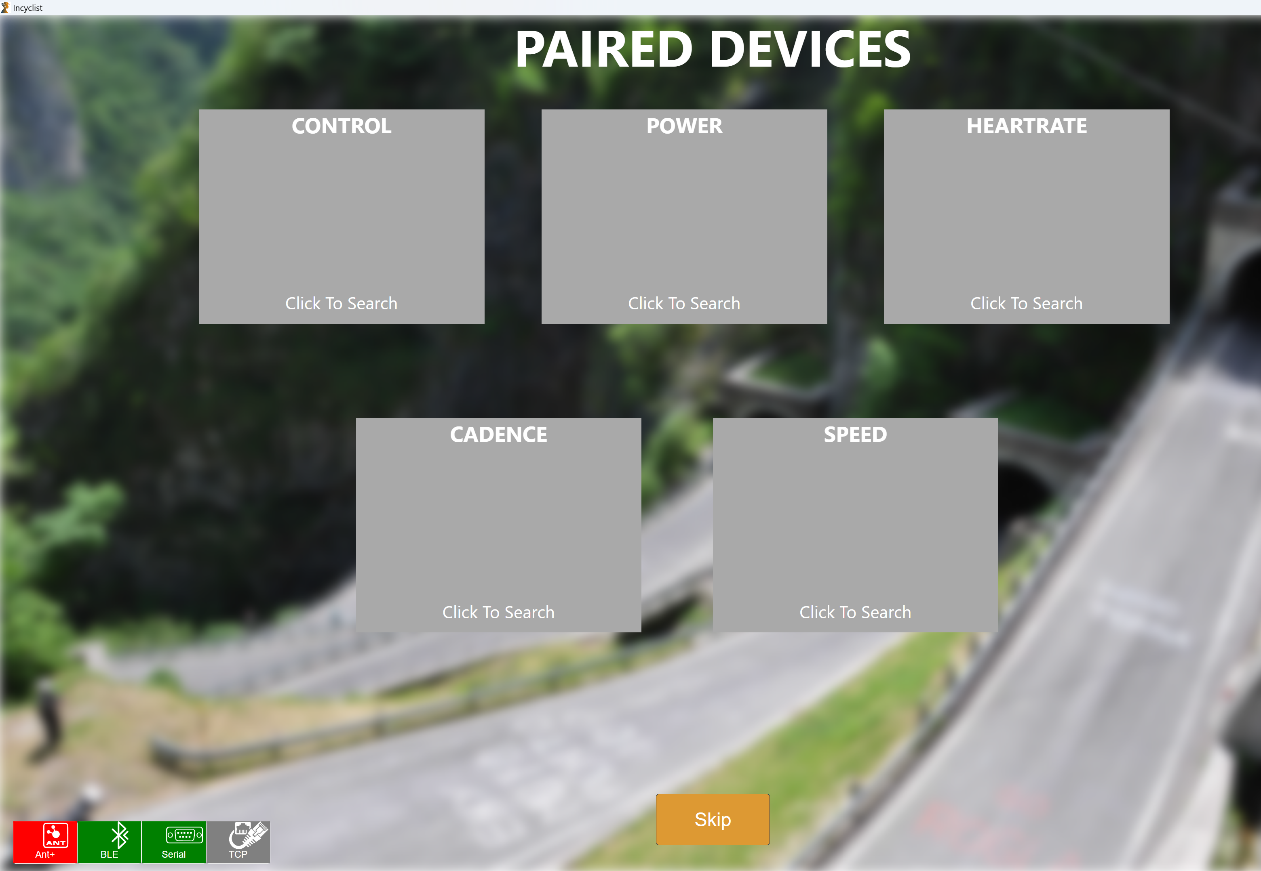
4. First click to search for devices to connect to, then select devices to connect to.  
   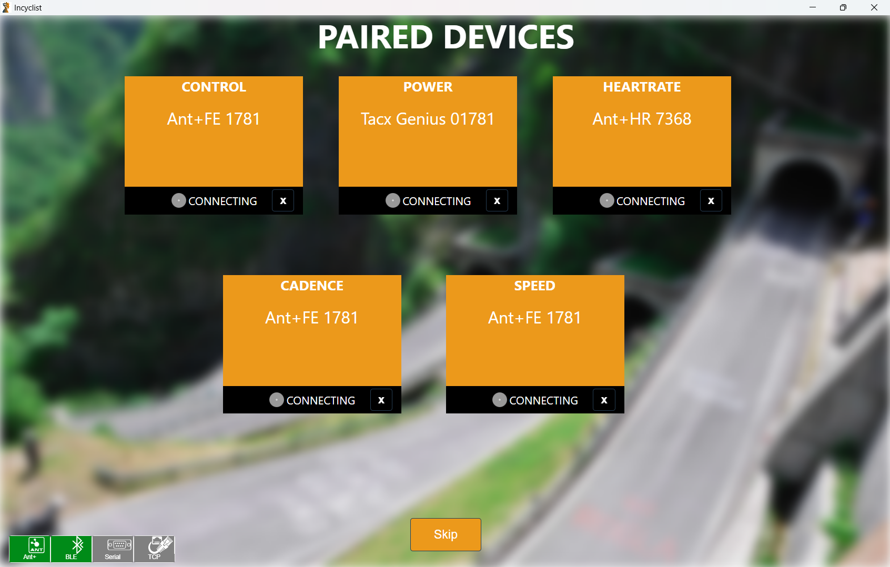  
     
   For some smarttrainers you have to select a specific protocol:   
   - Serial: Daum Classic, Daum Premium, Kettler  
   - TCP: Daum Classic, Daum Premium  
     
   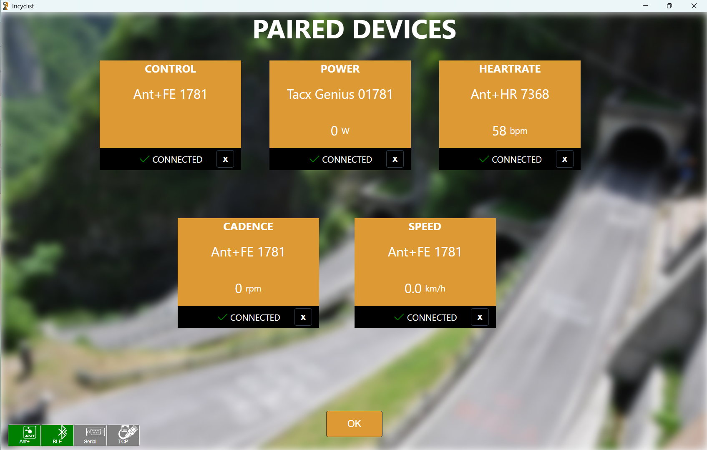  
   When everything is connected you can continue by clicking OK.
5. On the next screen, choose settings and fill in your name and weight. If you know your functional threshold power (FTP), add that as well:  
   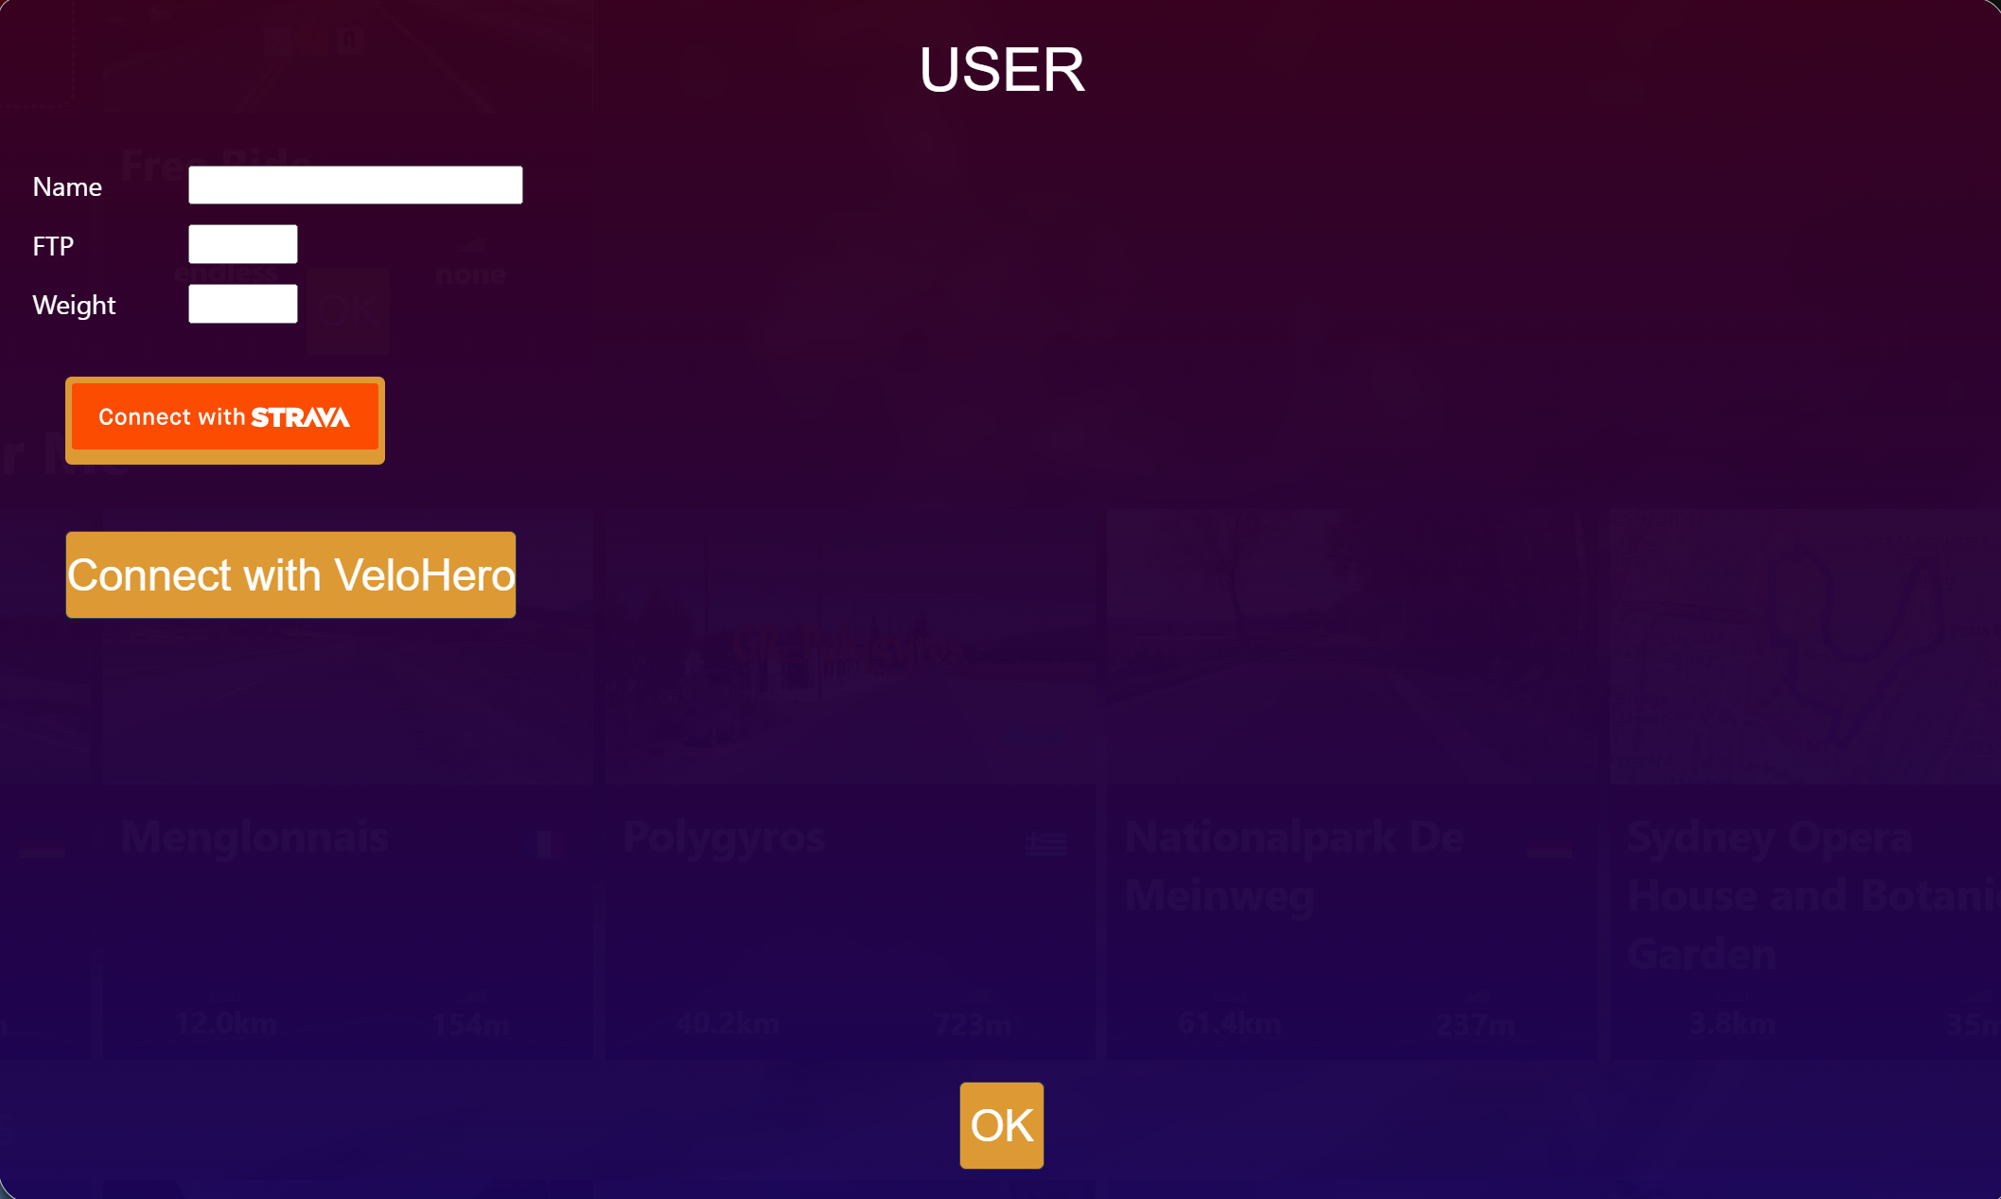
6. Then select a route, by clicking OK (thumbnail rotates to show an OK-button):  
   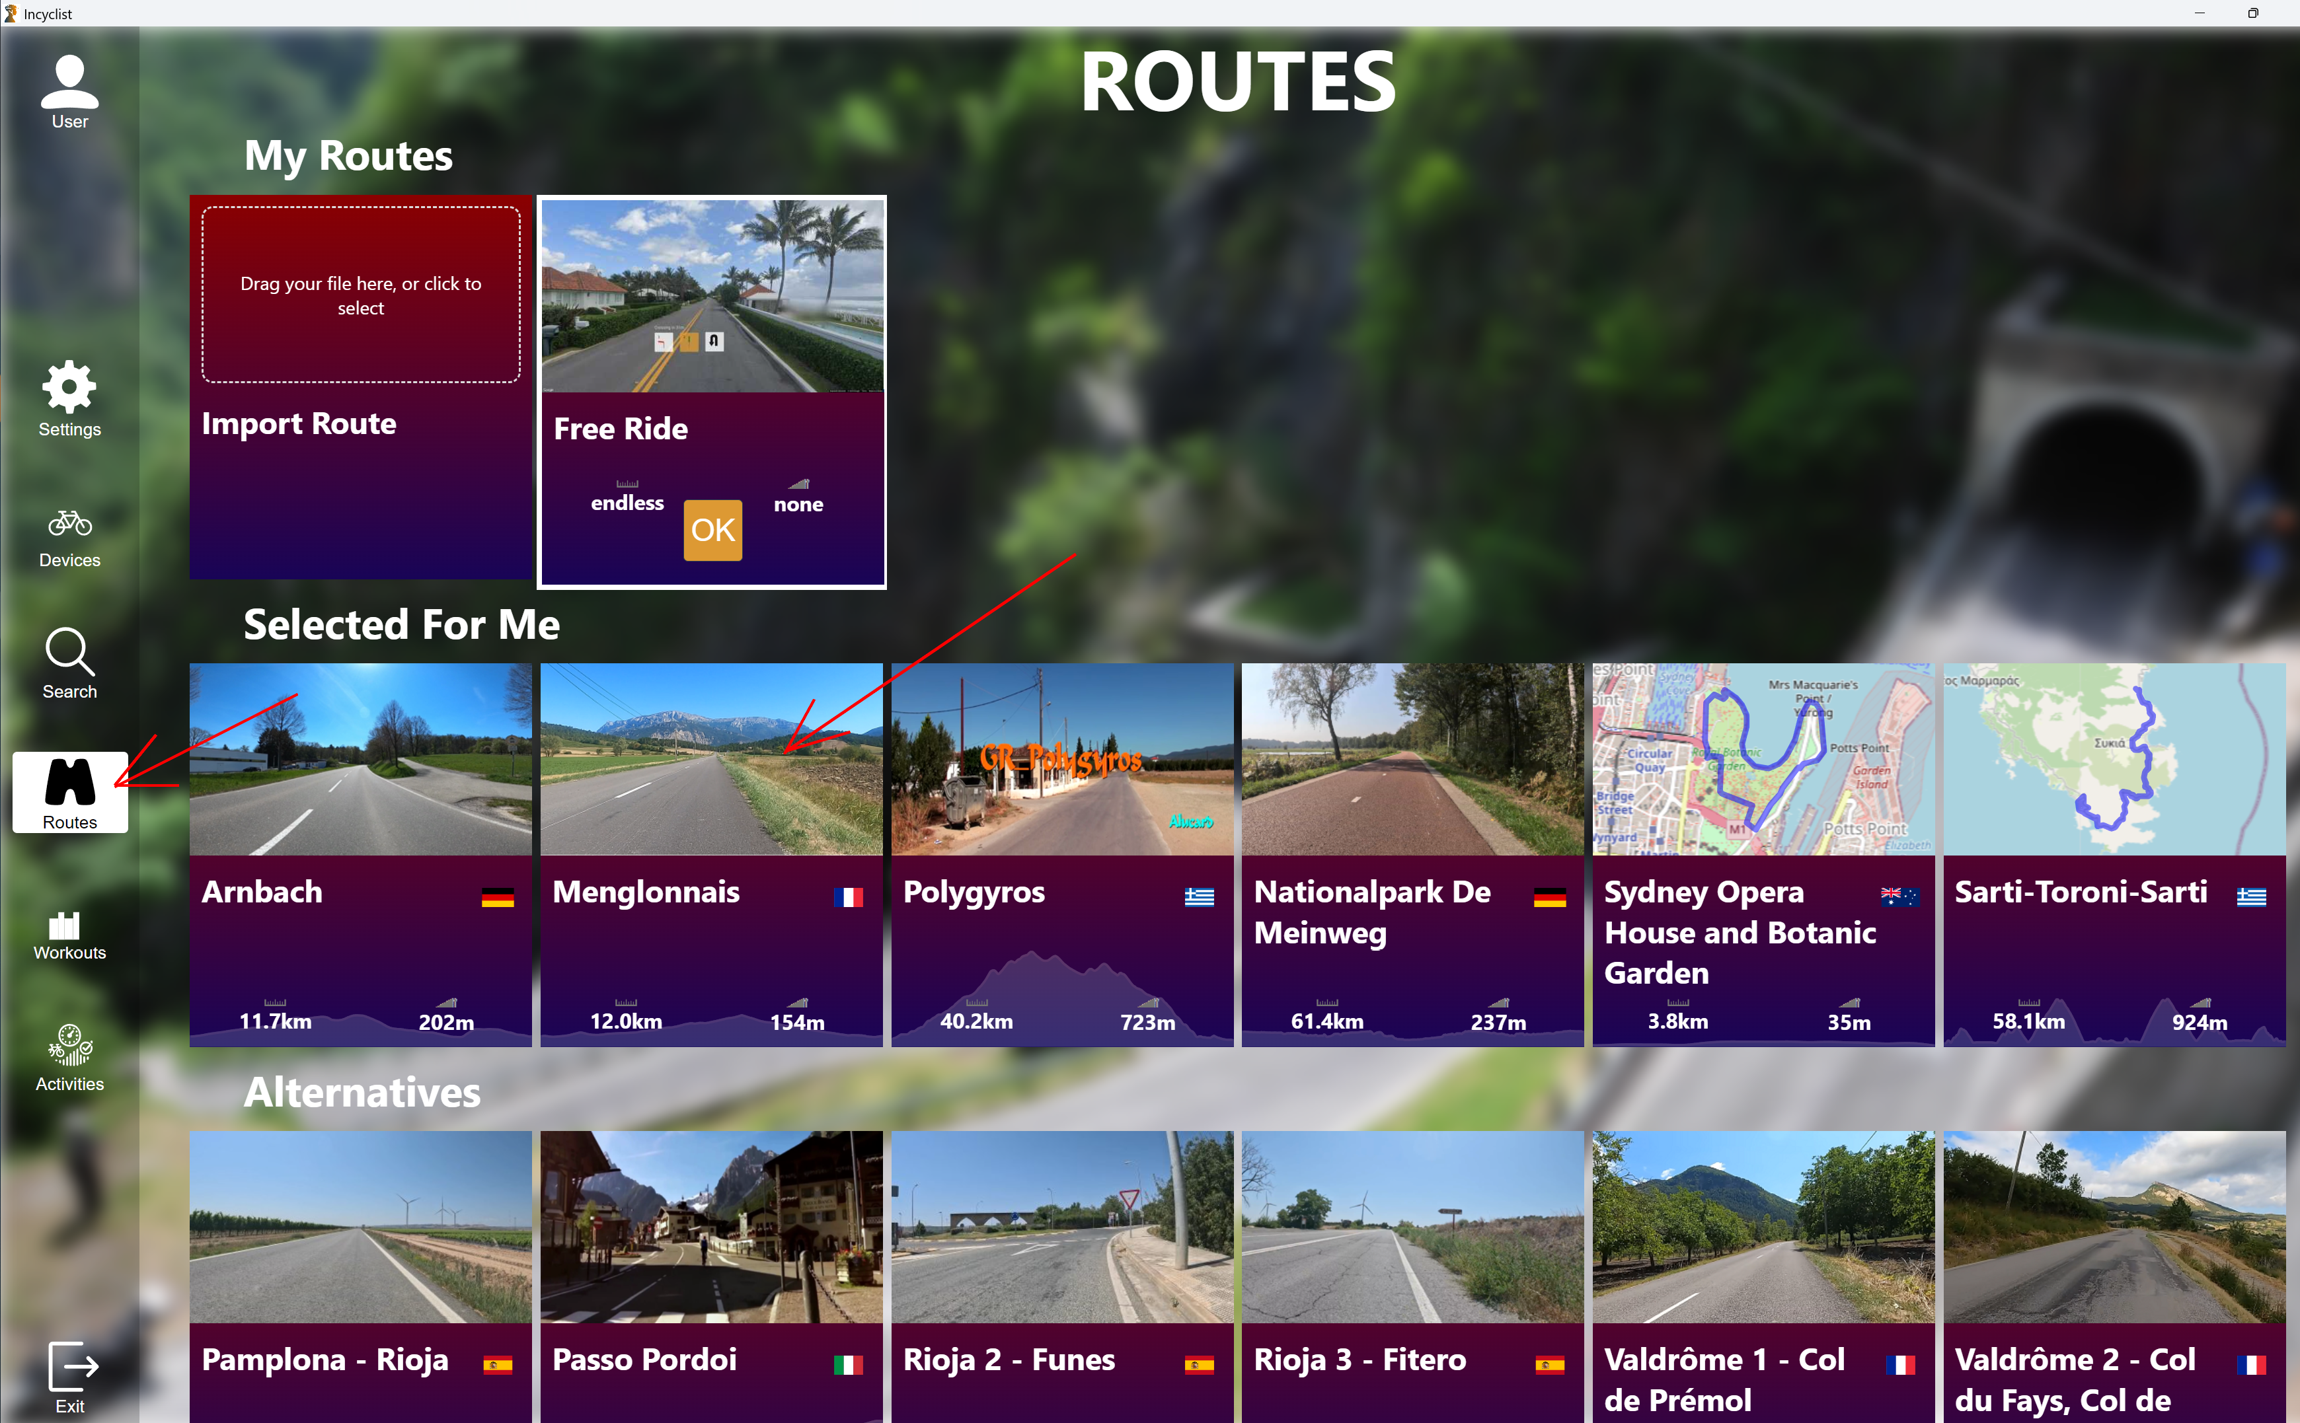  
     
   You can scroll to the right by clicking the green box with a white > sign on the main screen to find more Routes:  
   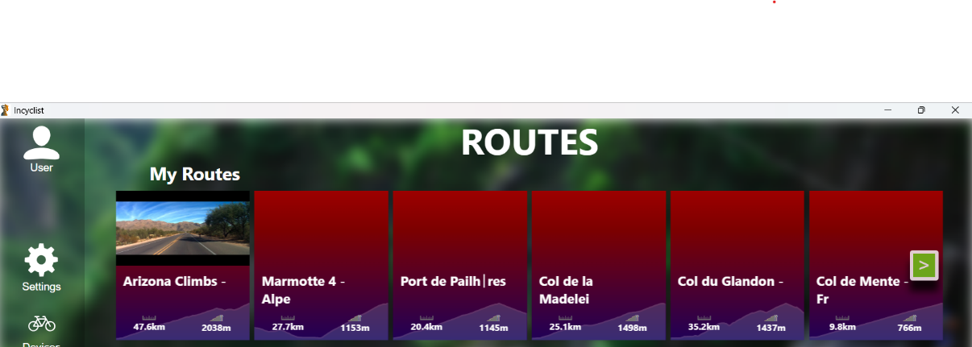  
   You can also move the bar with routes by keeping the left mouse button pressed and moving the mouse (drag mode).
7. 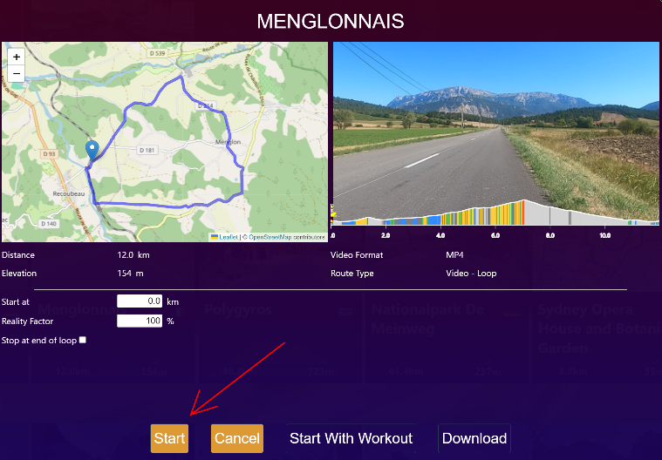Then start the workout by clicking Start:

# Hotkeys

Hotkeys that are available during a ride:

P: Pause activity (so that you can stop&save or resume)

S: Toggle Slope Preview (Top Right) on/off

E: Toggle Elevation View (Bottom) on/off

M: Toggle Map on/off

C: Toggle between Smart Trainer and ERG Mode (only if initial mode was [Advanced]   
 SmartTrainer)

H: Toggle all overlays on/off (view only video/GPX)

F: Toggle full screen mode

F10: Takes a screenshot

L: Toggle Left Side View on/off (GPX only)

R: Toggle Right Side View on/off (GPX only)

# Installing Incyclist and hardware setup

Installing on a Windows PC/laptop is straight forward; just download the setup file from <https://incyclist.com/> and install it. This is also the case for the Mac version.

The Mac-build so was unsigned for a long time, which caused warnings during the installation. These warning are now gone. However, there is a new warning now appearing when you launch the App: *'Incyclist wants to access key "Incyclist Safe Storage" in login keychain'*. An explanation and a recommended action for dealing with this is to be found on the [FAQ page](https://incyclist.com/faq/" \t "_blank).

For running on Linux Fred van Gestel has made a guide for a few ubuntu flavours: <https://cycling.vangestel.online/indoor/faq/incyclist-on-linux/index.html>

Incyclist can use Bluetooth or ANT+ to connect with a smarttrainer and a heartrate strap. Also a serial cable and WiFi are available, but for most people not needed. When opening Incyclist the option to scan for devices through one of these protocols can be switched off or on, by hovering above the button (left-under on the screen) and click the gear icon.

It is best to disable the interfaces that you know you are not using (for example serial), which probably will make the Device scan smoother

ANT+ is a multipoint-protocol and robust. If your smarttrainer is available to connect through ANT+ and Bluetooth doesn’t work well for it, use an ANT+ dongle!

If an ANT+ dongle is recognized the ANT+ button turns green, otherwise it is red. The same is true for Bluetooth and serial cable. If you have been busy with adding video’s and other stuff, the opening screen can show devices to pair with, but no sign of connection (or a button to connect):

In this case close Incyclist and restart the PC/laptop/Mac.

Direct Connect capable Smart Trainers, to which sometimes in the indoor cycling community is referred to as "wifi"-connected, are also supported. Direct Connect promises a much higher performance and robustness than ANT+ or BLE and most new smarttrainers support it.   
Note: On Windows, you will get a warning from the Firewall, when you activate the interface for the first time. Windows will ask you if you want to allow Incyclist to access your local network. This is required to scan for Direct Connect capable devices in your local network.

After installation Incyclist will try to update itself with newer versions. This normally happens upon launch. However, if downloading of the update takes longer than 3s Incyclist will continue with the current installed version and download the update in the background. The next time you start Incyclist, you should have the new version installed.

Windows users that use a Tacx ANT+ receiver to connect to their smarttrainers can download an USB-driver for the ANT+ receiver at the Garmin website for Windows 11 .

# Settings

## Gear

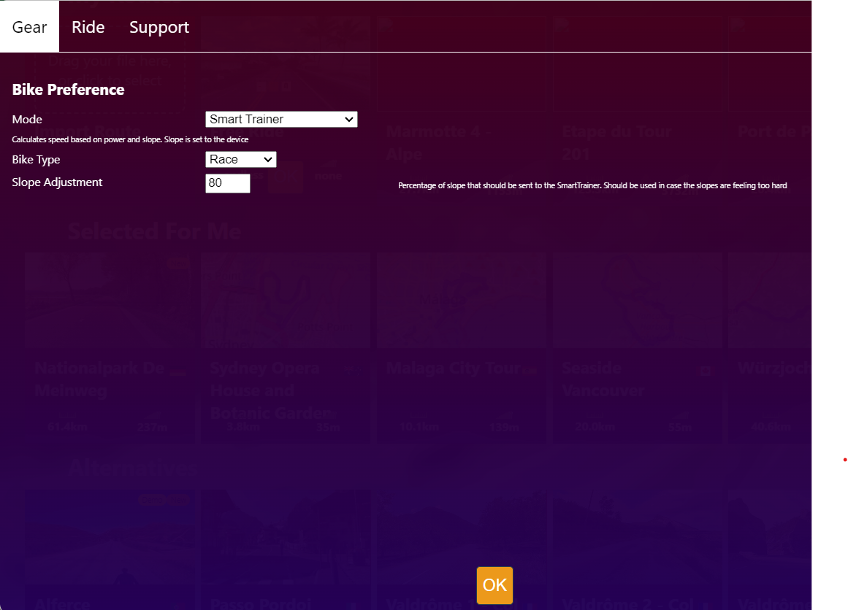

There several modes one can choose of; the choice of available modes do depend on your smarttrainer and the way you connect to it:

*I Communication over ANT+ with FE-C (transferring power, speed and cadence):*

1. Smarttrainer: resistance based on the Route or Workout that is chosen
2. ERG: constant resistance, regardless a certain cadence
3. Advanced smart trainer (will probably disappear as an option in the future): it is the same as SmartTrainer-option, but offers the option to cap the maximum power. This means that when you are above the maximum configured power output (from the ride settings), it automatically switches to ERG mode and keeps the resistance on the predefined maximum power-setting

*II Communication over Bluetooth with FTMS (also transferring power, speed and cadence)* offers a more limited set of options: only Smarttrainer and ERG.

*III Communication over ANT+ with PWR (power)*: only Powermeter (just reads the values and calculates speed based on the power delivered).

*IV Communication over Bluetooth with CP (power)*: only Powermeter.

*V Daum Premium:*

* *Daum Classic*: uploads the route at the beginning of the ride to the Daum smarttrainer, the Daum takes full control and Incyclist only displays values that the Daum registers.
* *ERG*: this is similar to the ANT+/Bluetooth ERG mode, but you can adjust power by switching gear or drastically adjust cadence - so power is not enforced)

The available bike types (race, mountain and triathlon) currently only have impact on the ride physics, which is determined by the underlaying model that Incyclist is using. This concerns things like the speed that is calculated based in ERG- and SmartTrainer-mode. Bike type also influences how the Incyclist calculates the resistance, based on wind resistance and rolling resistance.

Slope adjustment can be used if one wants to have an easier (or heavier) ride; it alters the power needed to ride up bridges/hills/mountains. For example: if you have 50% Slope adjustment in the slope would be 10%, the app would send 5% to the trainer and thus the trainer would set the resistance to a lower value. This can be used to fine-tune your trainer if slopes are feeling harder indoors than in reality.  
The Slope adjustment isn’t the same as the Reality factor that can be set when one starts a certain ride. When you change the reality factor, it will impact the way the speed is calculated in the app based on slope & power. For example, on uphill sections you will be faster with the same power output. One can use this while doing interval sessions, to get the same speed reported by Incyclist as a connected bike computer does.

## Ride

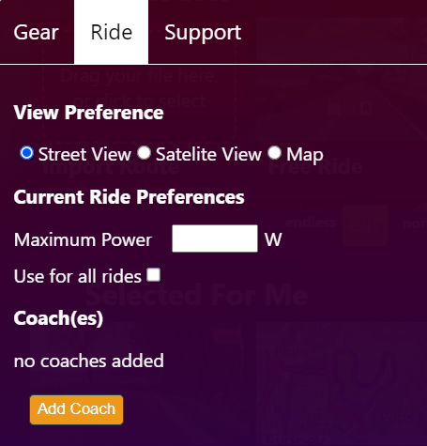

In the ride setting one can specify what Incyclist shows if a ride is imported without a video (GPX-import for example). With streetview Incyclist gets streetview-images from Google for the location that the rider is at. Satellite view and map view show the rider as an avatar on a satellite image or a map.

One can specify a maximum resistance (power needed) that the smarttrainer is allowed to deliver.

A "coach" is a simulator (and associated avatar) that performs the ride with a pre-defined speed or power - you could say as a pace makerIn the coach settings, you can create one or more of these coaches which then will be shown during the ride.

## Connecting to Komoot

It is possible to connect to Komoot, after one has added credentials for it in the settings:

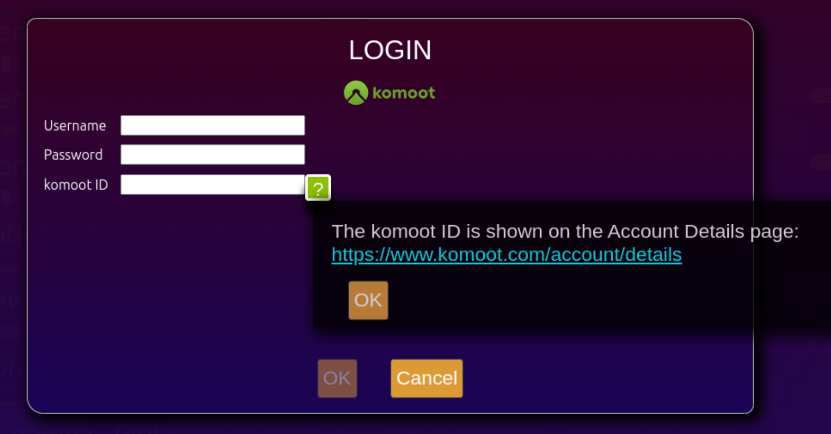

The Komoot ID can be found within Komoot, in the user settings.

The first sync can causes some delays in Search screen and also some (temporary) blank items in the list. As the number of routes in a Komoot account can be huge, a search can be done to find one. This not only searches in the Komoot routes, but also in the other routes that were available in Incyclist:

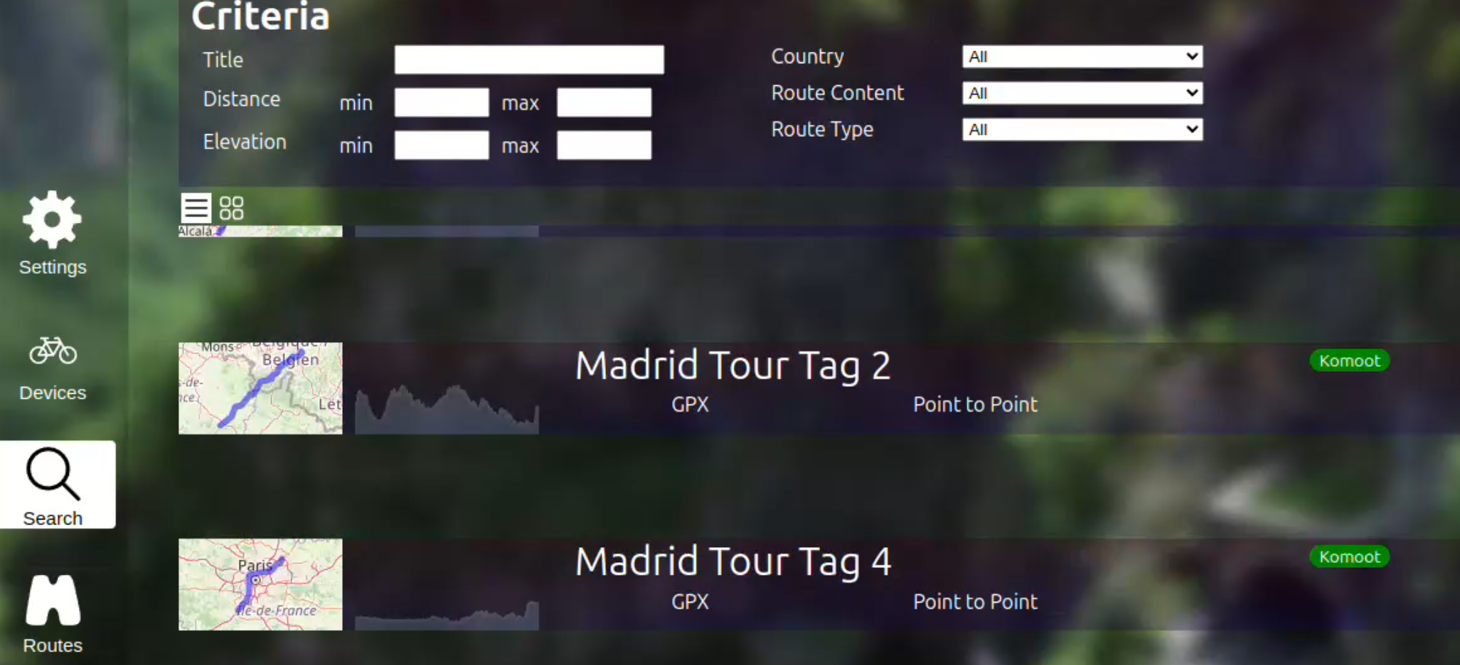

## Connecting to other platforms

Under the Apps setting one can also make the connection to Strava (or VeloHero). It opens a new screen when selected, so that one can make the connection with that platform:

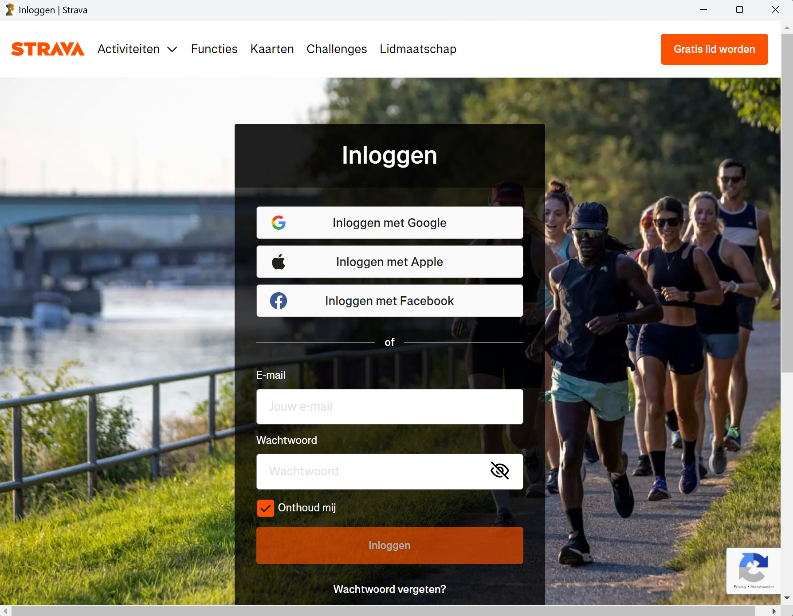

The idea is to add more platforms in the future.

# Importing routes/courses/tracks

One can add routes/courses/tracks by clicking on the plus-sign in the main screen of Incyclist or draaging files to it:

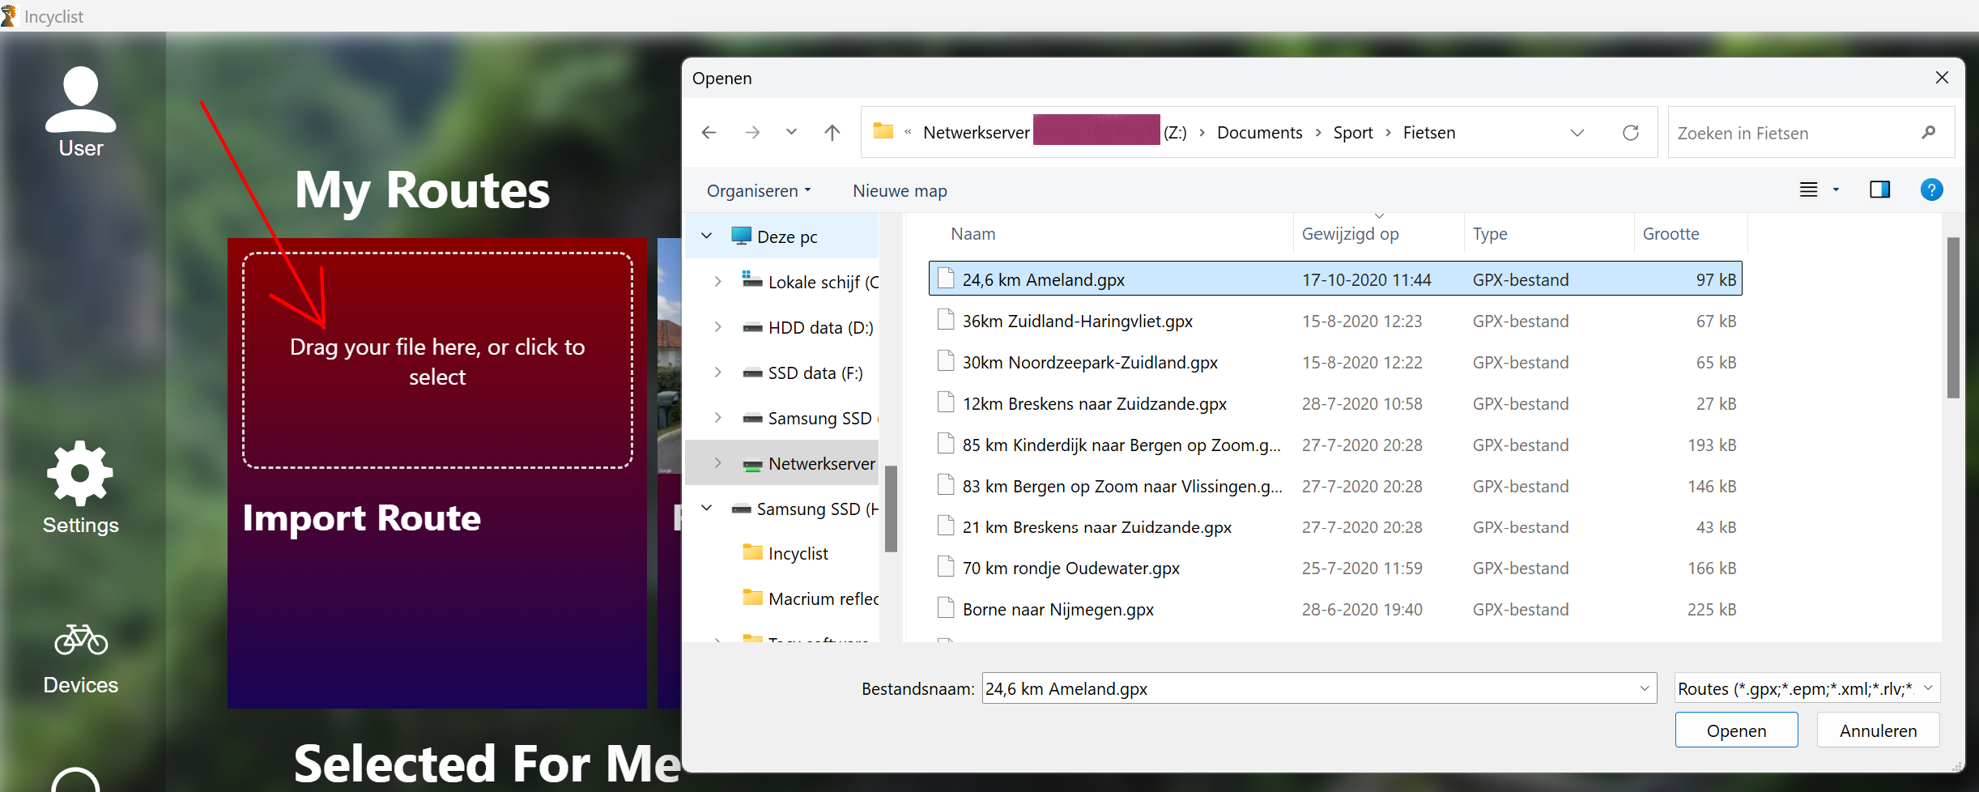

Available options are:

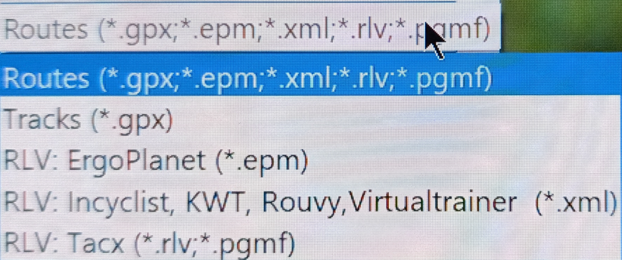

# Using routes with RLV’s (real live video’s)

Incyclist offers the possibility to ride a virtual route, based on a prerecorded route:

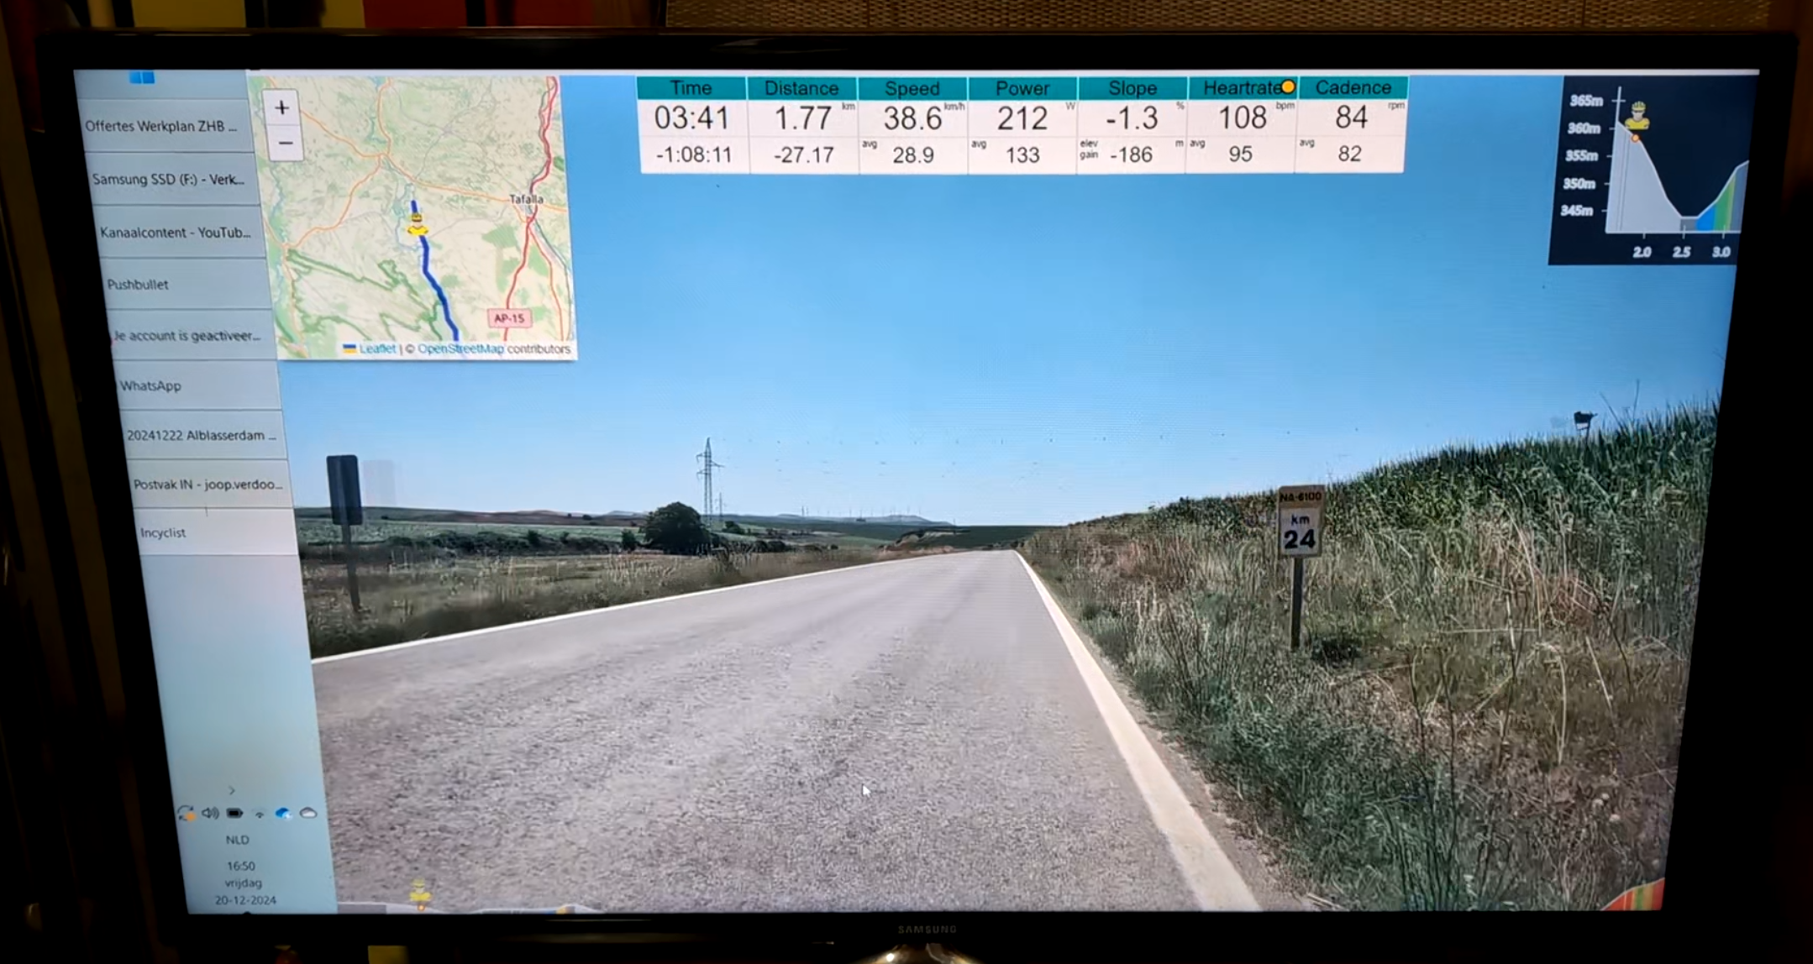

This requires the video file and an extra file for position information. RLV’s can be found under the Routes-option:

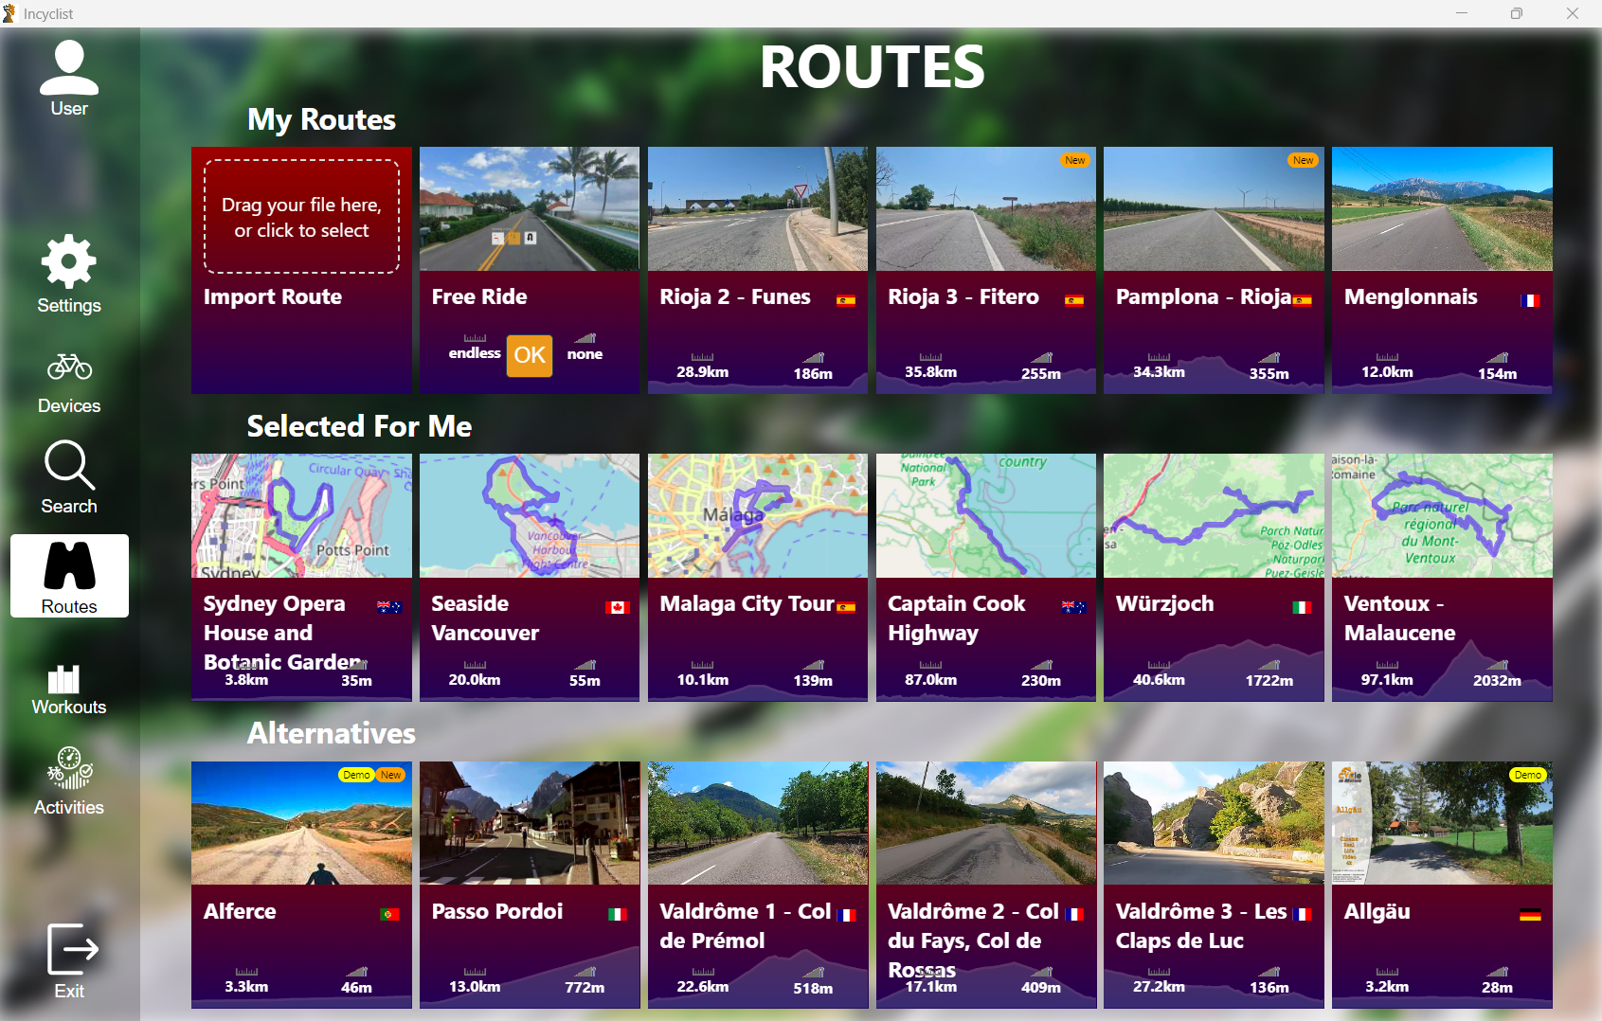

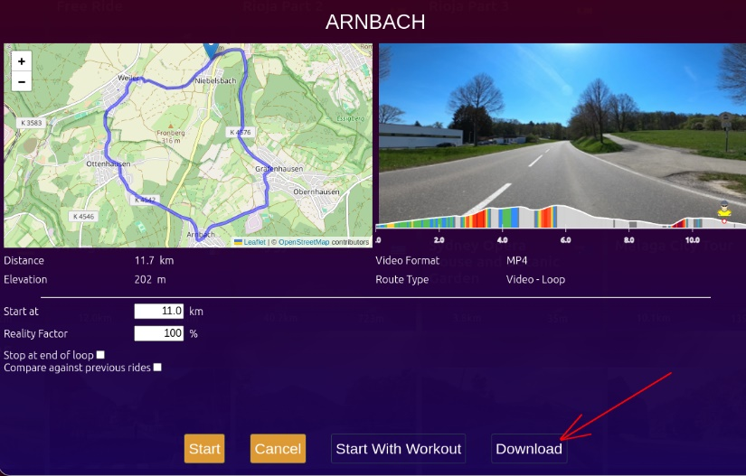There are built-in routes. The best way to use them is to download them first, as internet connection speed on the server side is limited and image quality will suffer a bit.   
When hoovering above a route, the OK-button can be pressed. On the page that comes up, the Download option can be chosen:

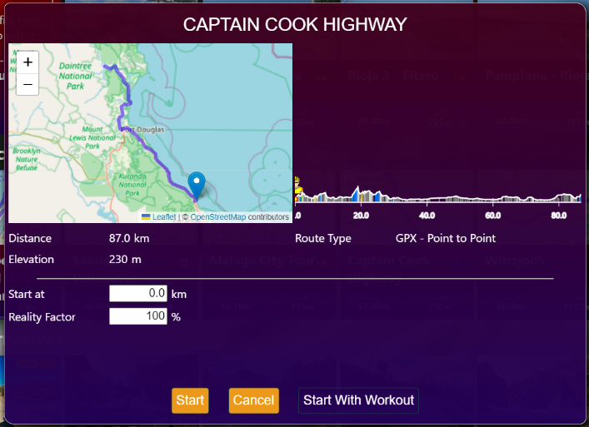Depending on your internet connection speed the download takes a few minutes or more. File sizes vary from 700 MB to 6 Gb.

After completing the download the workout can be started and the video will start if you start to peddle:

Options that are available:

* Starting position of the ride (works only with MP4-videos - preset to the previous position ridden)
* Segment (works only with MP4-videos - in case the video offers segments that defined that start and end position)
* Reality Factor: Adjust the slope used for the calculation of Speed (10% slope adjustment would mean that a 5% slope would be considered as 0.5%). Reduced slope is also sent to device if in in the general settings of Incyclist, with SmartTrainer mode selected, a percentage lower than 100% is given
* Stop at end of a loop. If a video is a loop and you want to do one, you can select the ride to stop at the end of the first loop. If not selected, the route will continue for another lap
* Compare against previous rides is shown when there was already a ride with the same start position and the same reality factor. This will result in showing your position during the ride in previous rides as avatars
* Stop at end of current movie. This option is only available for movies that can be ridden in sequence, for example Pamplona Rijia, Rioja 2, Rioja 3. If selected, the ride will stop at the end of the video. If not selected, the ride will be automatically continue with the next video in the sequence and resulting in a near seamless longer “journey”

## RLV’s for download by others

Several users of Incyclist have created their own RLV’s, which are free for use and can be downloaded:

* https://rlv.nielspn.synology.me/index.php/incyclist-video (only available during a limited amount of hours per day)
* <https://cycling.vangestel.online/indoor/videos/>   
  Fred van Gestel also explains how to make one’s own RLV’s on his website!

There are also paid downloads of RLV’s:

* <https://www.cycle-in-motion.de/>
* <https://www.reallifevideo.de/incyclist.php?lang=en>   
  Carsten has the HD-version of “De Meinweg” for sale, for example, which is available in SD-format within Incyclist
* <https://www.real-life-video.nl/>
* <https://www.bikelabshop.it/en/>
* <https://www.fitviewer.com/indoor-cycling-videos.html>

## Adding other RLV’s to Incylist

Installing downloaded and compatible RLVs on Incyclist is quite easy, you just need to follow a few simple rules. Start Incyclist and choose Import Route:

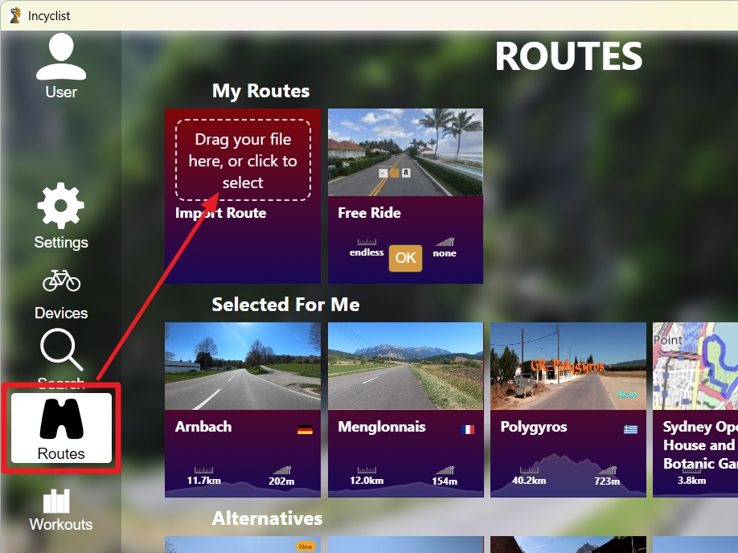

Navigate to your RLV files and maps:

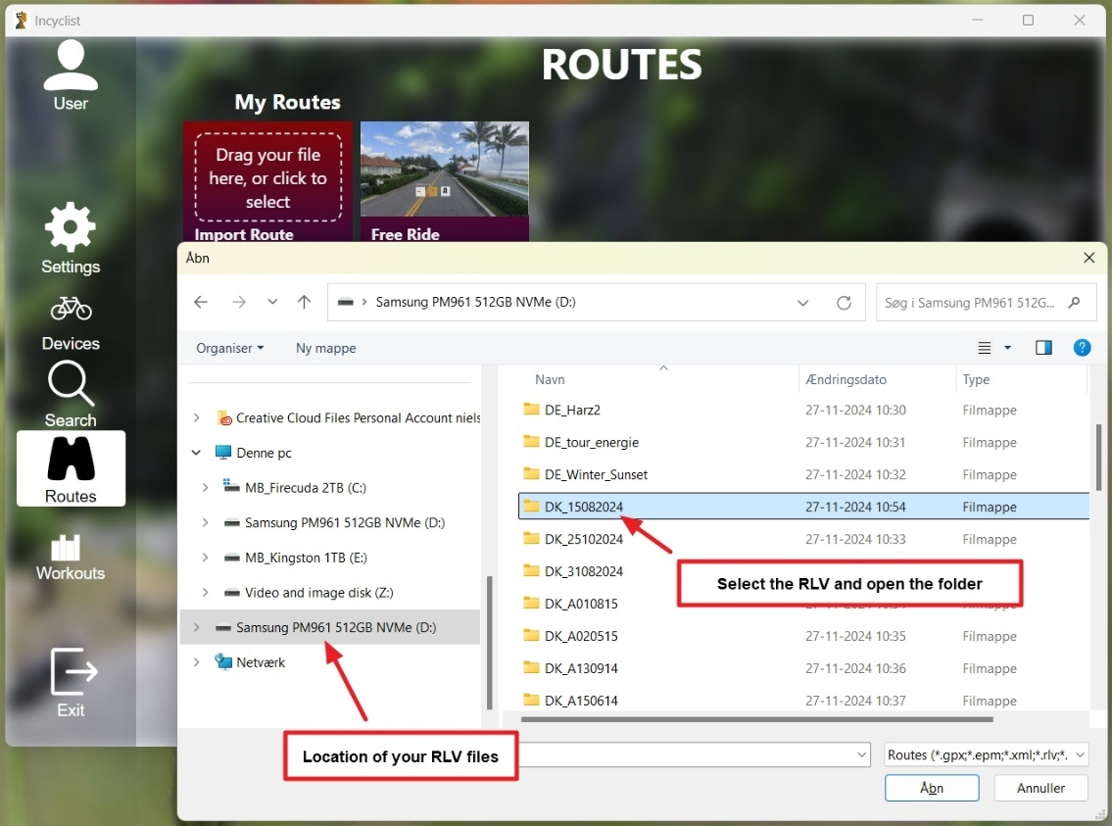

Click on the .XML file (or the pgmf-file if you have been converting old Tacx video’s) and then click Open:

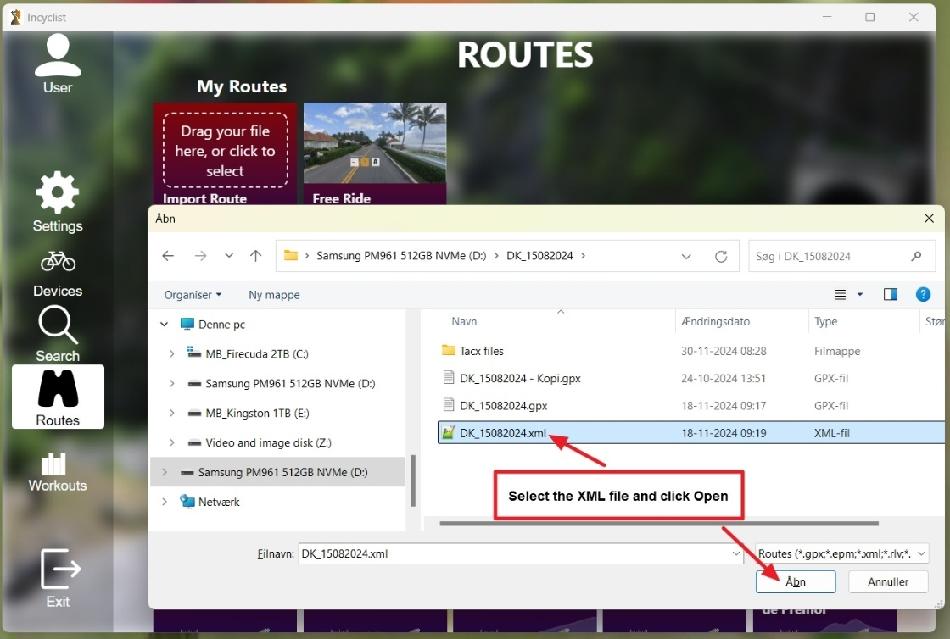

The RLV is now imported and ready to use:

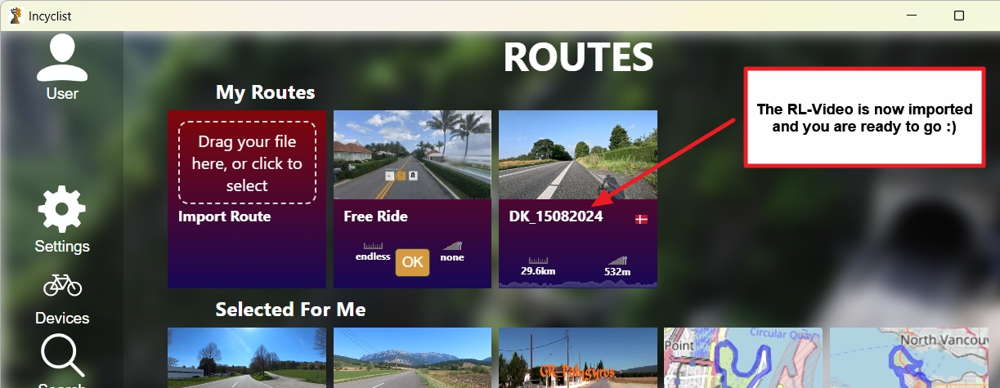

If you had added a route by a .pgmf-file a .rlv-file with the same is needed as well in the same directory as the .pgmf-file. Also Incyclist must be told where the .mp4-video is located as well.

After importing you must not change the folder name or the name of the files in the folders - if you do, they will no longer work within Incyclist!

If you get the error “no matching parser found” the input file that you used isn’t supported by Incyclist:

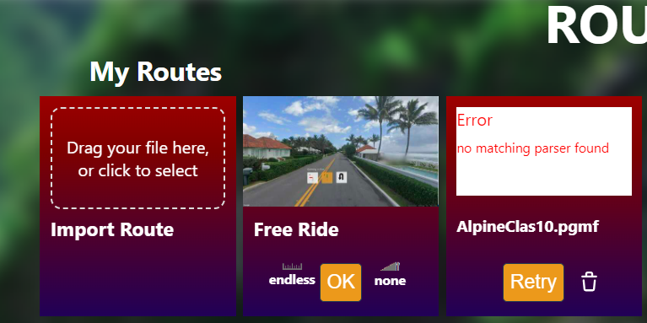

## Converting your own Tacx videos from the Tacx Training Software

It is possible to use your old Taxc videos, when you had installed them inside the Tacx Training Software. In the appendix the process of converting is described. Beware that currently the end result isn’t perfect by far; the video’s accelerate and decelerate constantly.

# Using routes without video’s

When you want to use a ride without a video, the following options are available:

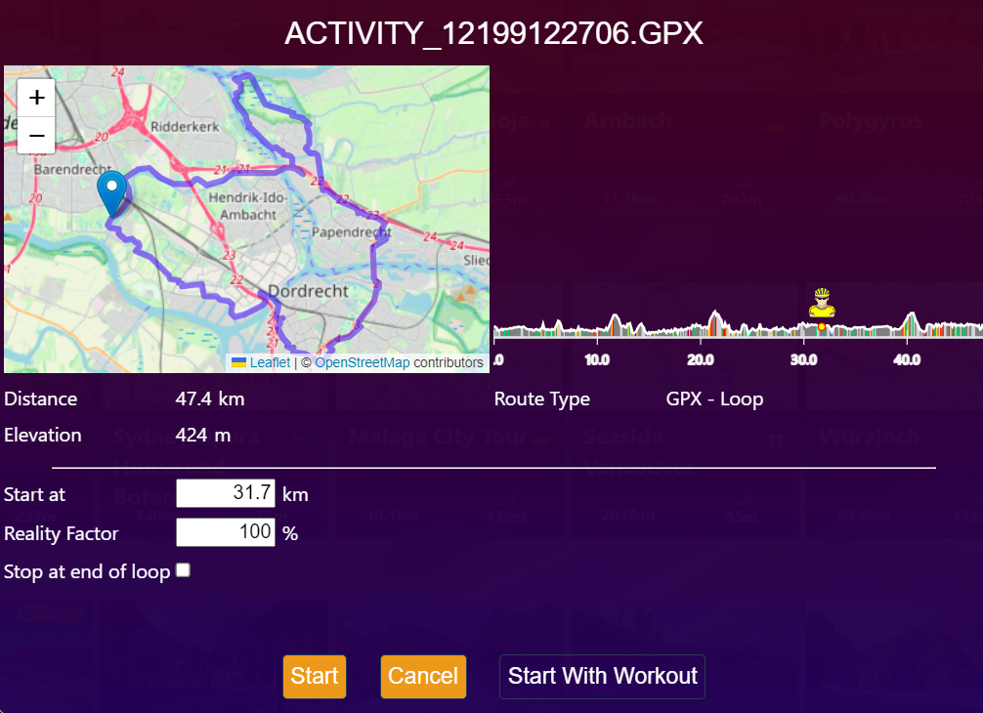

You can start at any point in the route, by giving in a km-point; the avatar will show the location in the height profile. The reality factor can be changed, to make the activity easier or harder.

When start a route without a video the same options are available as a route with a RLV (see that paragraph for an explanation of the options):

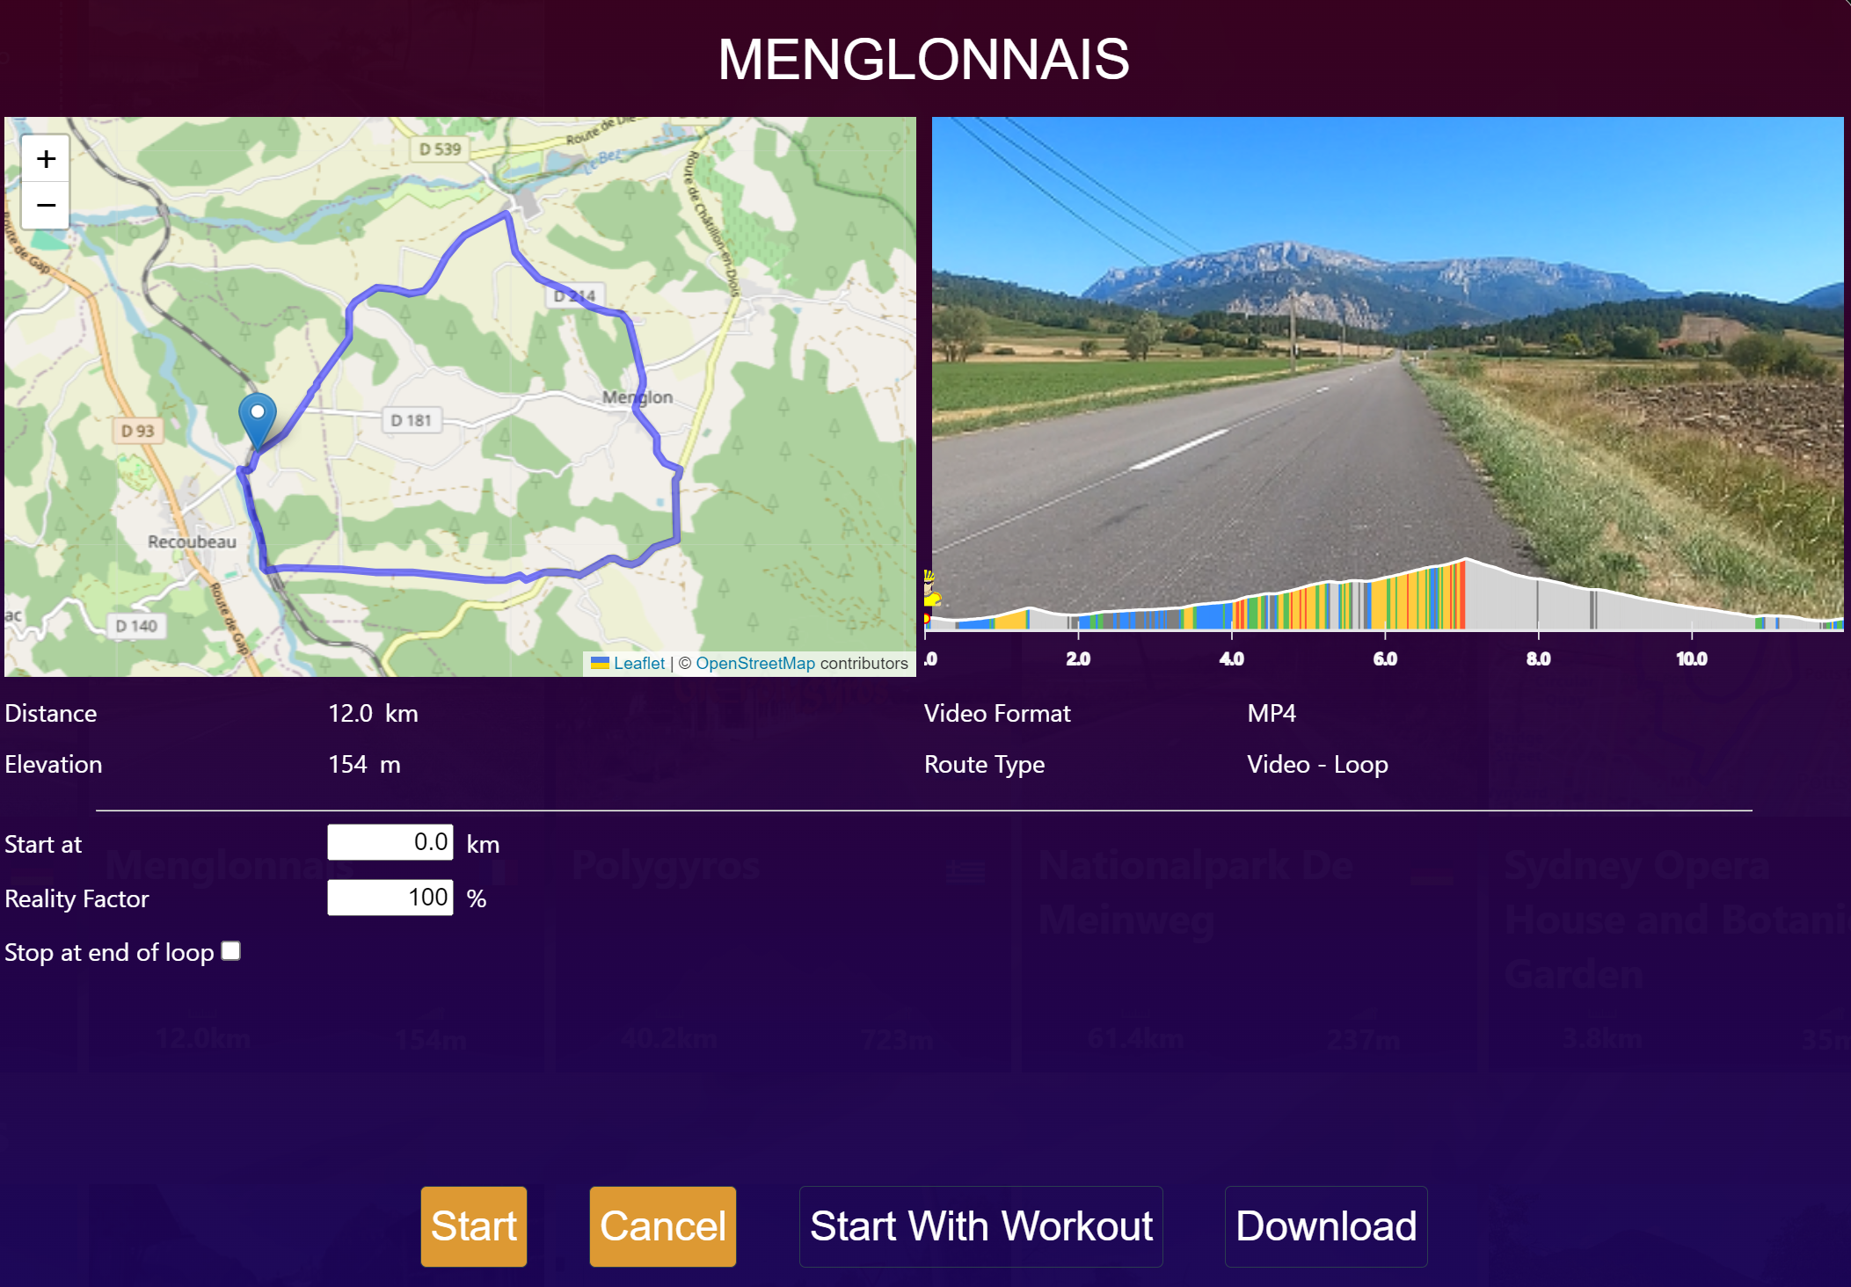

# Using workouts

In the workout-section you can import predefined workouts, that must have a zwo-extension (Zwift workout file):

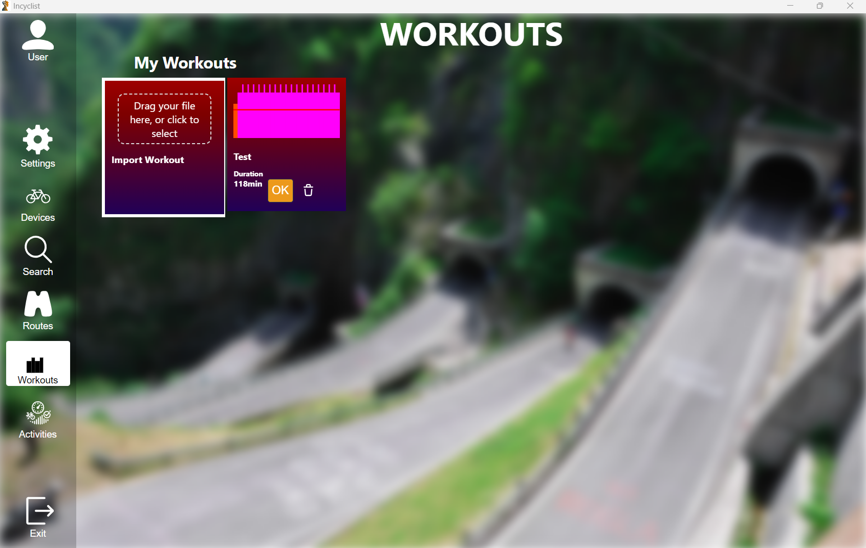

Besides downloading workouts from Zwift there are also other options:

* Convert workouts from other formats (or even a gpx-file) to the .zwo-format at <https://whatsonzwift.com/convert>
* Create a workout at <https://zwofactory.com/> or <https://www.zwiftworkout.com/>   
  In Incyclist the ZWO-fatcory-tile brings you right away to ZWO factory, where you can create a workout. You must save the workout locally on your PC, by using the download option. After that you can import the workout in Incyclist using the most upper left tile:  
  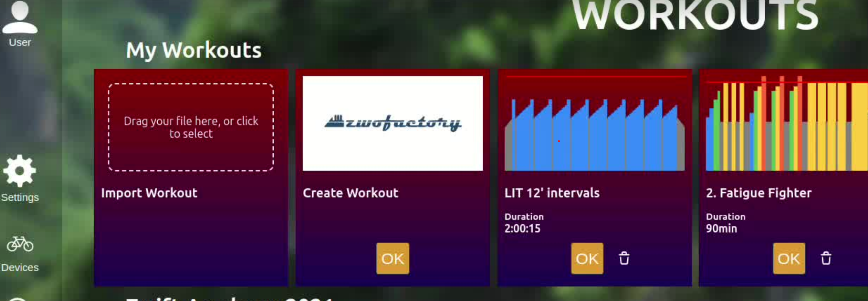
* Download a workout from TrainerRoad in zwo-format

After double clicking a workout tile , the FTP value can be set, whether ERG-mode should be used before the workout is selected to start:

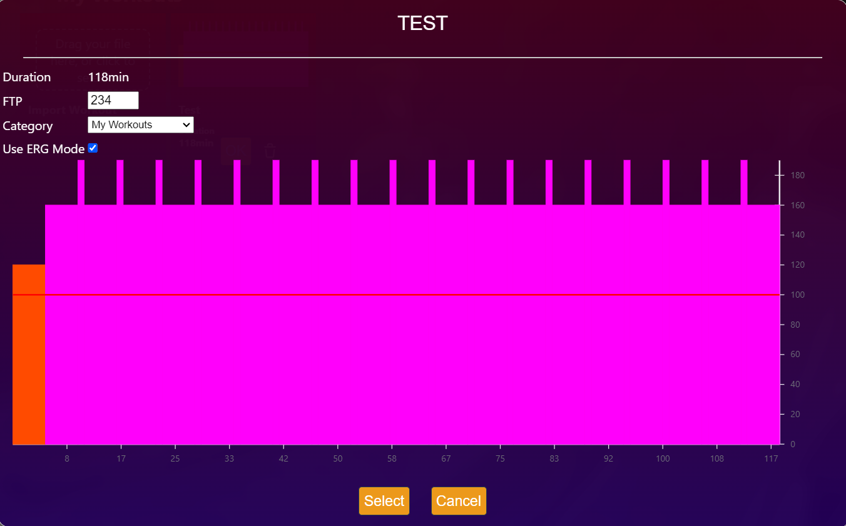

# Activities

If you choose Activities in the main screen of Incyclist, you will be able to view activities that you have done earlier:

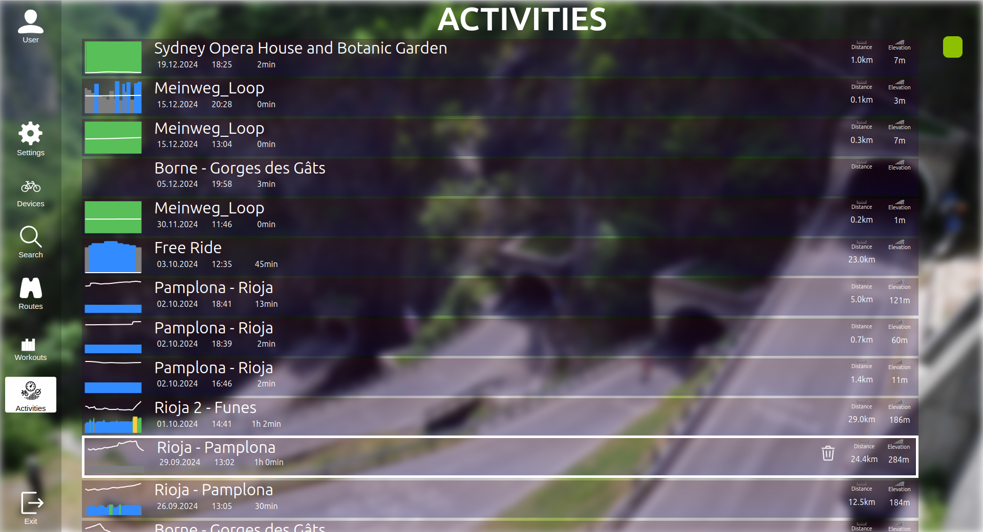

You can view them after clicking on them, also there’s an option available then to ride the same route again (as race against yourself) - assuming that the route is still present in the Routes list:

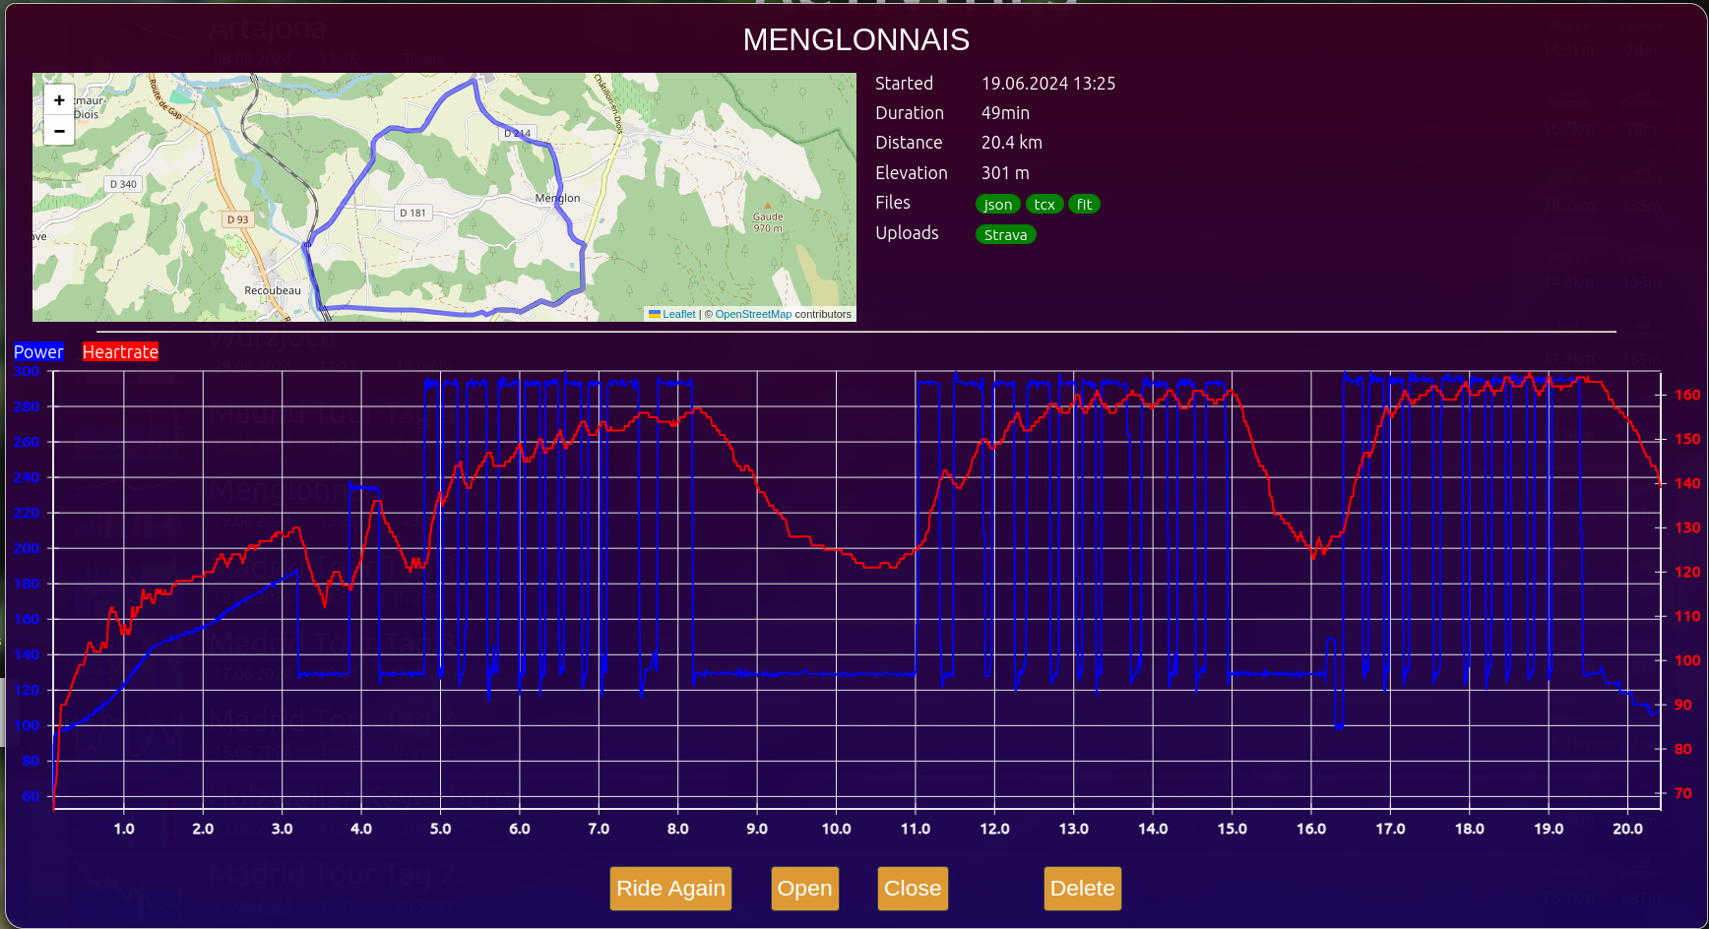

For racing against yourself and seeing additional avatars, indicating the positions of yourself in previous rides, it is required to have exactly the same starting position and reality factor (the %-factor, how hard or easy a ride should be). The option "Compare against previous rides" also needs to be checked for this.

You can also do a manual export to TCX/FIT and/or uploads to Strava/VeloHero, which might be required if you forgot to press save at the end of the ride (or if there were problems during the upload). Older activities might not show the correct upload status (they all appear in grey = unknown) as the author of Incyclist started to track the upload status since beginning of November 2024.

# Appendix 1

If you have the Tacx Tacx Training Software installed and had Tacx DVD’s added to it in the past, you can use them in Incyclist as well. As described in the main text of this manual, currently the result of the conversion isn’t really usable because of the constant speed changes. This is visible in one the resulting files (the .rlv-file):

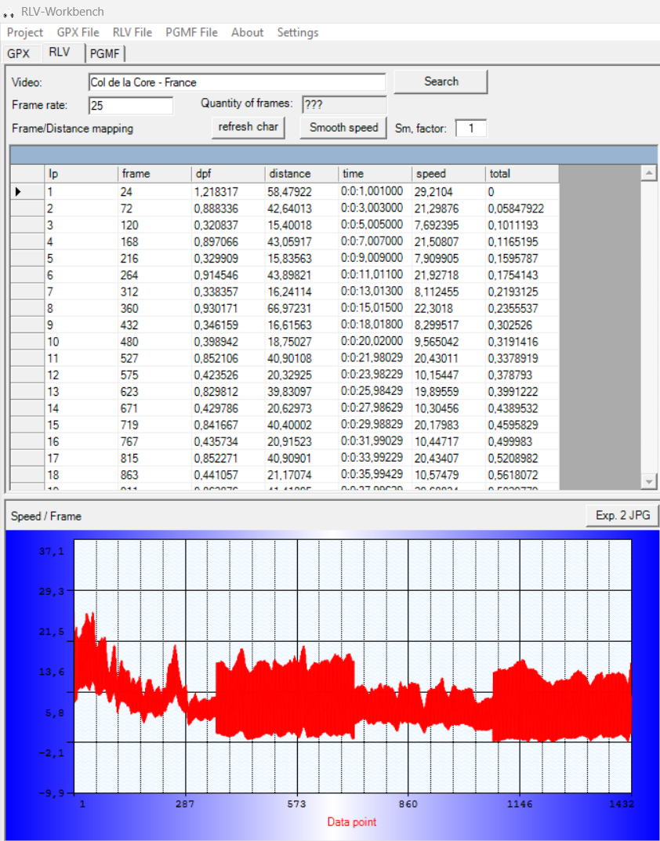

But as one can try things and maybe have better results, hereby the steps of the conversion process.

You need the .tts and .avi-flies for each DVD. The .tts-files need to be converted to .pgmf- ànd .rlv-files, which can be done in this way:

1. Download from <https://github.com/ericchristoffersen/MorphSat_Public>. On this Github web page you must click 'tags' on the right and then the latest version (V0.15 at this moment), and then you are able to download a zip file (MorphSat\_V0.15.zip at this moment).  
   PS: for more info on MorphSat visit <https://lunicus.org/Forum/viewtopic.php?t=686>
2. Put all .tts file in one directory and extract MorphSat.exe to the same directory
3. Create a batch file with the following contents (see <https://www.geeksforgeeks.org/how-to-create-a-batch-file-in-windows/> on how to do that):  
     
   @echo off

setlocal enabledelayedexpansion

set "file="

for /f "delims=" %%a in ('dir /b \*.tts') do (

set "file=%%~na"

)

if "%file%"=="" (

echo There are no .tts-files found in this directory.

pause

exit /b

)

for /f "tokens=1 delims=." %%a in ('dir /B \*.tts') do "MorphSat.exe" -i "%%a.tts" -o "%%a.rlv"

for /f "tokens=1 delims=." %%a in ('dir /B \*.tts') do "MorphSat.exe" -i "%%a.tts" -o "%%a.pgmf"

if exist "%file%.rlv" (

echo Converting tts-files to rlv- and pgmf-files has ended. Press to end.

pause

exit /b

) else (

echo Converting tts-files to rlv- and pgmf-files was not successful. Press to end.

pause

exit /b

)

1. Double click the batch-file.  
   This converting process takes a while, depending on the configuration of your Windows PC/laptop.  
   The result is a set of .rlv files, while the tts.files are kept as well (but not needed for Incyclist).

The .avi-fles need to be converted as well, which can also be done with a batch file. This requires ffmpeg:

1. Download ffmpeg from <https://www.ffmpeg.org/download.html>. Unzip the contents and note where ffmpeg.exe is located. In this example it is: C:\Users\John\Downloads\ffmpeg-7.0.1-full\_build\bin\ffmpeg
2. Create a batch-file with the following contents:  
     
   @echo off

setlocal enabledelayedexpansion

set "file="

for /f "delims=" %%a in ('dir /b \*.avi') do (

set "file=%%~na"

)

if "%file%"=="" (

echo There are no avi-files found.

pause

exit /b

)

for /f "tokens=1 delims=." %%a in ('dir /B \*.tts') do C:\Users\John\Downloads\ffmpeg-7.0.1-full\_build\bin\ffmpeg -i "%%a.avi" -vf "scale=1920:1080:force\_original\_aspect\_ratio=decrease,pad=1920:1080:(ow-iw)/2:(oh-ih)/2,setsar=1" -c:a copy -y "%%a.mp4"

if exist "%%a.mp4" (

echo Conversion from .avi-files to.mp4-files has ended.

pause

exit /b

) else (

echo Converting .avi-files to.mp4-files didn’t succeed.

pause

exit /b

)

1. Double click the batch-file.  
   This converting process takes a quite a while, depending on the configuration of your Windows PC/laptop. It took 9 hours to convert 20 avi-files on a Ryzen AMD 5700+ 8-core CPU desktop PC, a laptop would a haven much longer to perform this  
   The result is a set of .mp4 files, while the avi.files are kept as well (but not needed for Incyclist)
2. Copy the .mp4-files to the same directory as where the .pgmf- and .rlv-files are copied to
3. The .avi-files need to stay out of this directory with .mp4-files, only after adding the RLV’s to Incyclist (see next paragraph) they can be placed in the same directory as the .mp4-files.

Note 1: the text that is coloured gray needs to be on one row in the batch file!

Note2: this batch-file converts the video’s to a fixed size of 1920x1080 pixels, adding black borders if needed. It is possible to set a higher number of pixels if one is using a screen that has more then 1920x1080 pixels.

Note 3: not all tts-file can be converted to pgmf- and rlv-files. Most of them can, though.

Note 4: some avi-files can also not be converted. This can be because there are special characters are used, although they aren’t visible in Windows. Try to rename those AVI temporarily to something simple, like VID1.avi. Renaming them back afterwards (including the freshly generated mp4’s) is required.

Note 5: some users experience in a constant changing of video speed in a converted Tacx video. This is most likely caused by the MorphSat (rapid jumps in speed). You can visit <https://github.com/ericchristoffersen/MorphSat_Public/issues> to check out whether is issue is resolved. At <https://lunicus.org/Forum/viewtopic.php?t=686> the author of MarphSat has explained a bit more about the usage of this tool.